Meeting Minutes

9/24/2018 – Kick off meeting

Attendees: Seher, Yi, and Serena

* Discuss part A requirements
* Scheduled a meeting with Professor Chipidza





9/27/2018

Attendees: Seher, Yi, and Serena

* Meet with the instructor to discuss the concept and initial set of user stories.
* 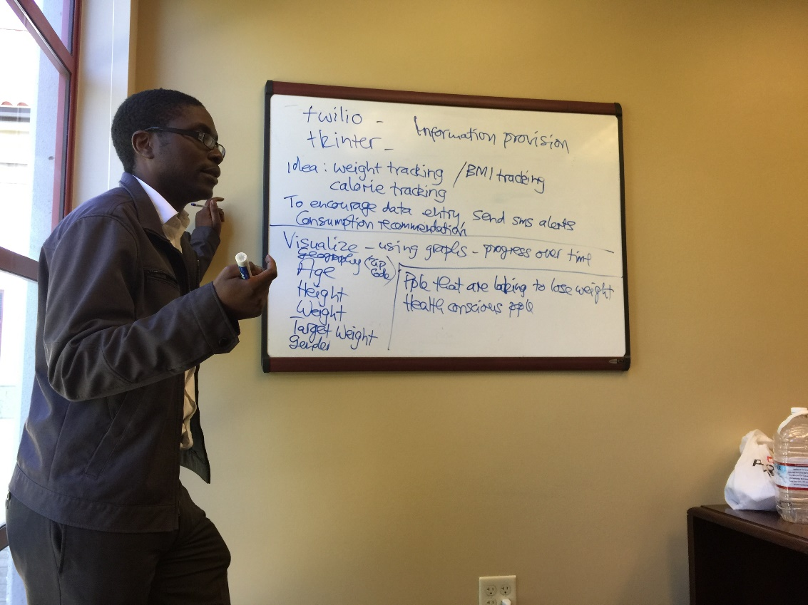Agreement between group and instructor on what is to be delivered

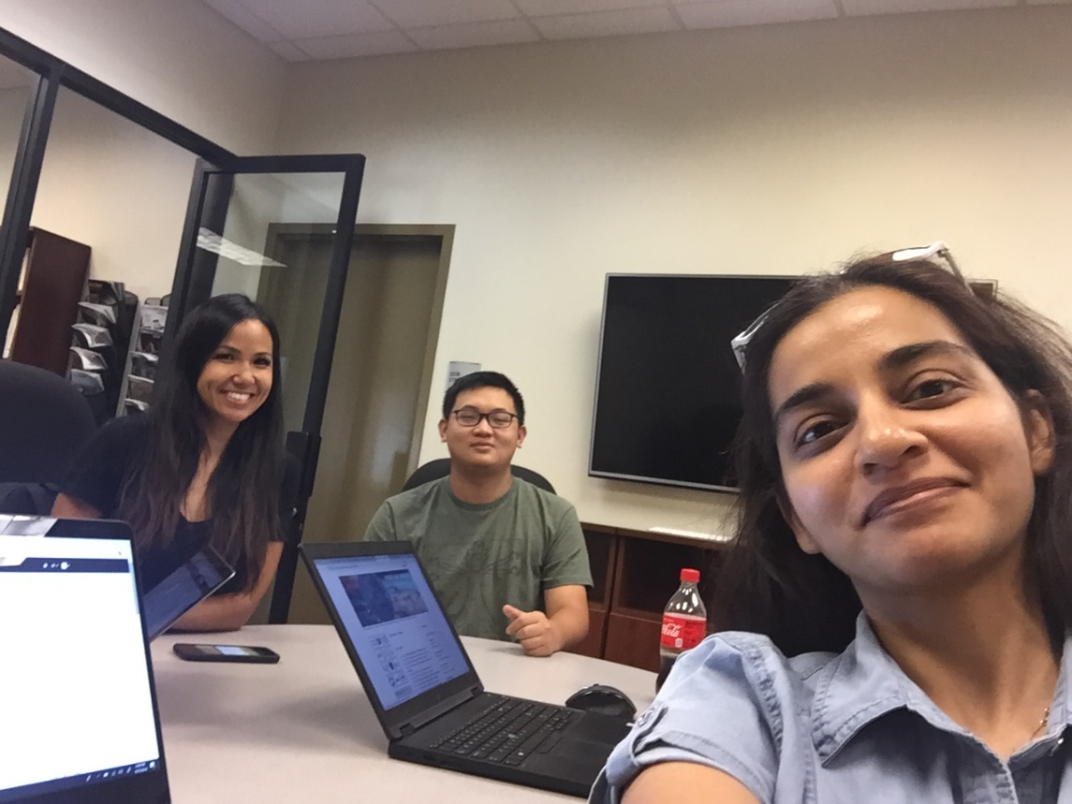

10/2/2018

Attendees: Seher, Yi, Alaa, and Serena

* Discuss project and when to meet next

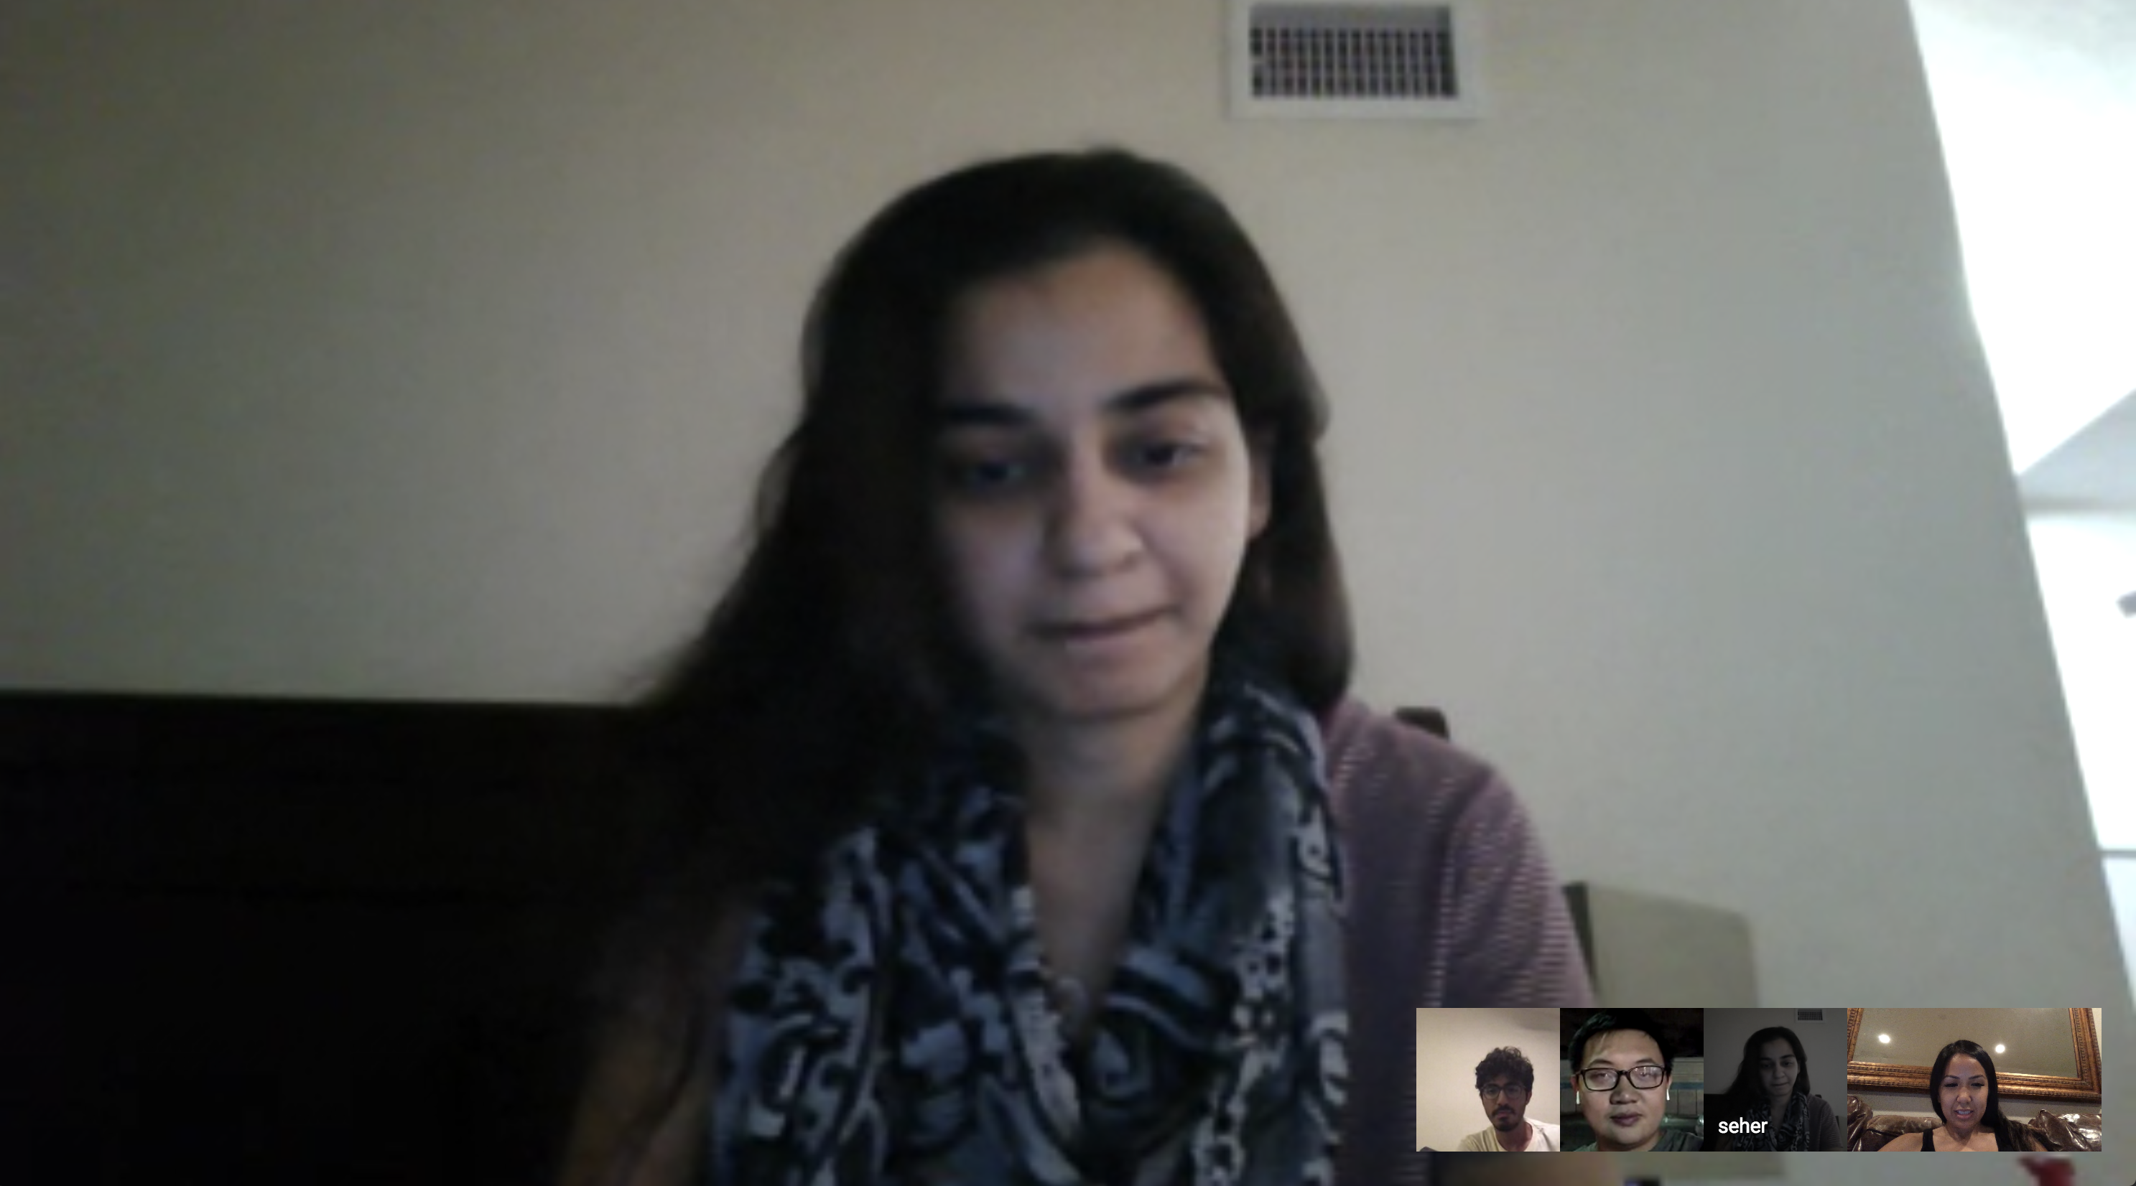

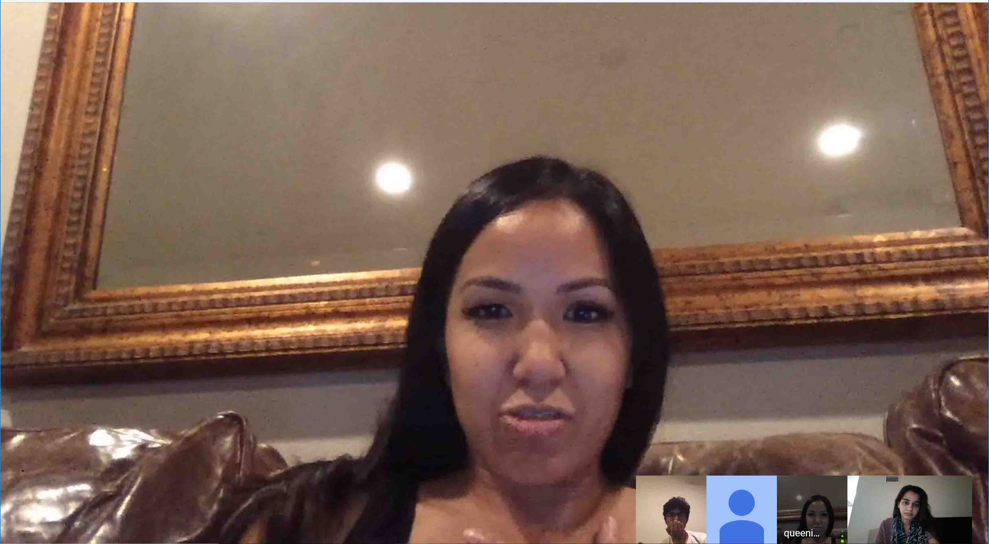

10/4/2018

Attendees: Seher, Yi, Alaa, and Serena

* Design BigFit application
* Discuss what we will be working on iteration 1

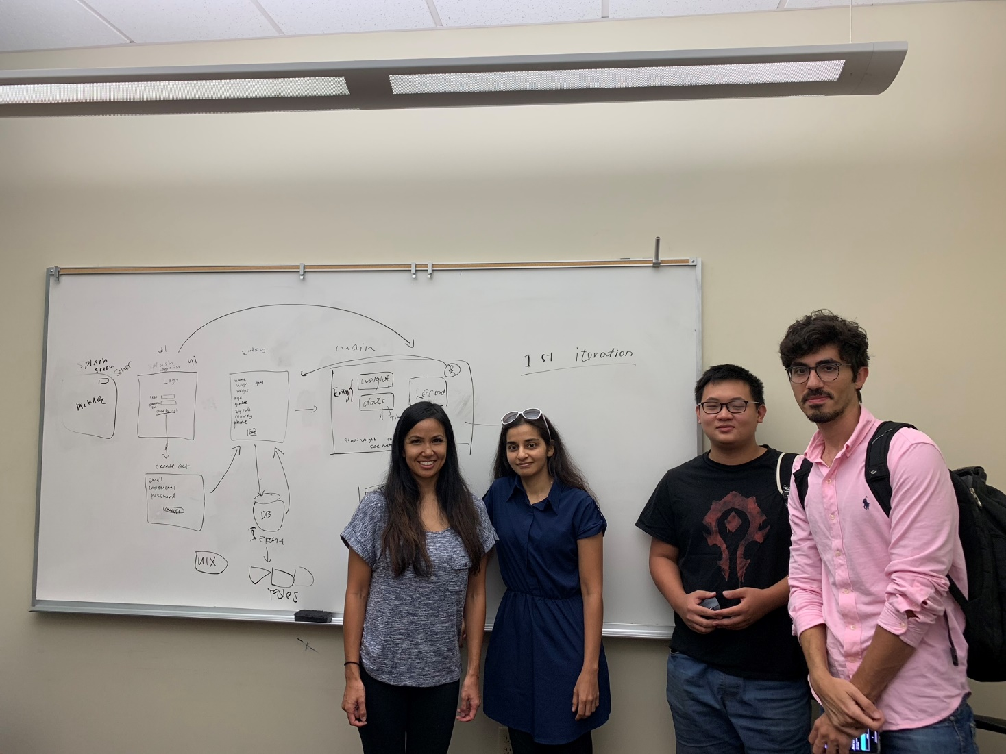

10/11/2018

Attendees: Seher, Yi, Alaa, and Serena

* Discuss front end tools to use

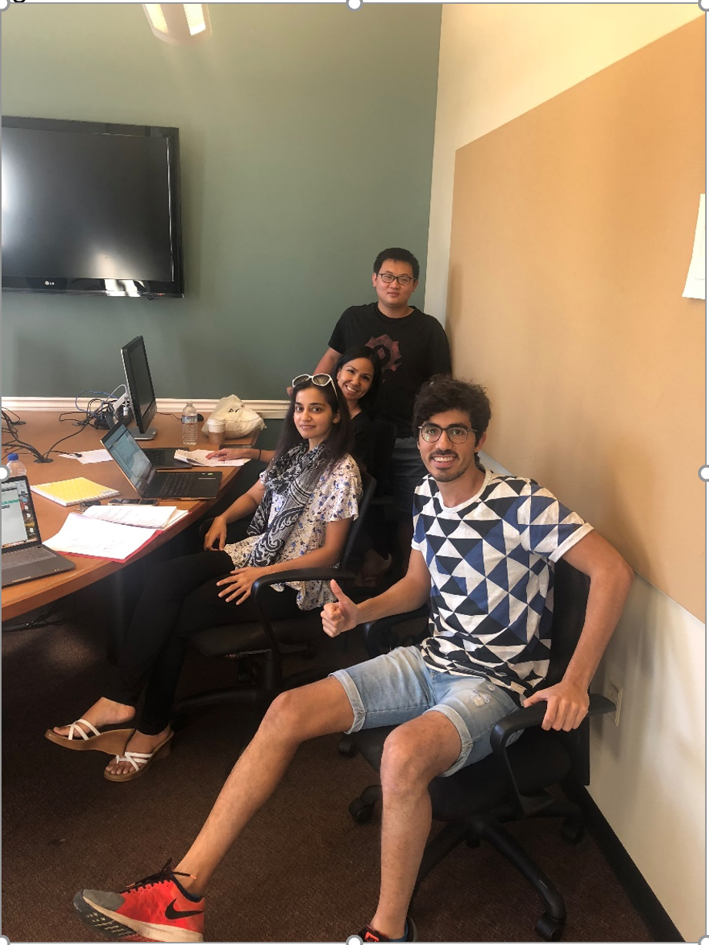

10/18/2018

Attendees: Seher, Yi, Alaa, and Serena

* Discuss Part C

11/1/2018

Attendees: Seher, Yi, Alaa, and Serena

* Quick stand up meeting

11/7/2018

Attendees: Seher, Yi, Alaa, and Serena

* Google hangout meeting to discuss any issues

11/8/2018

Attendees: Seher, Yi, Alaa, and Serena

* Finish coding for Milestone 1 and prepare presentation

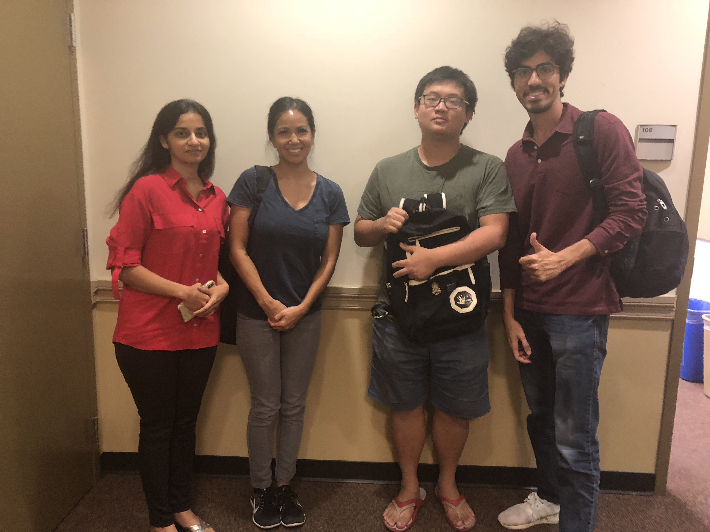

11/19/2018

Attendees: Seher, Yi, Alaa, and Serena

* Google hangout meeting to discuss any issues

12/3/2018

Attendees: Seher, Yi, Alaa, and Serena

* Google hangout meeting to discuss any issues

12/10/2018

Attendees: Seher, Yi, Alaa, and Serena

* Google hangout meeting to discuss any issues
* Prepare final presentation

12/13/2018

Attendees: Seher, Yi, Alaa, and Serena

* Final Presentation